Mark Kardash

11 January 2024

SDEV 400 6381

My successfully launched AWS:

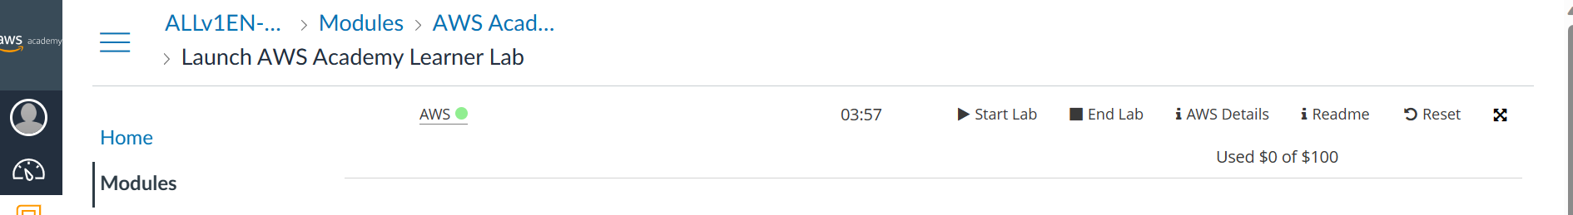

For some reason, that same page did not show my email address, so I had to click on “Account” to show it:

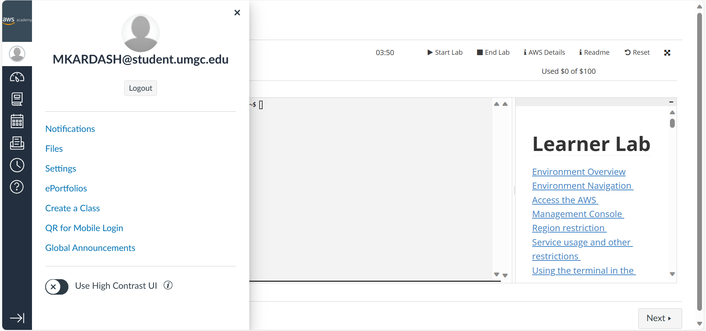

And here is my page inside the lab, with my email this time:

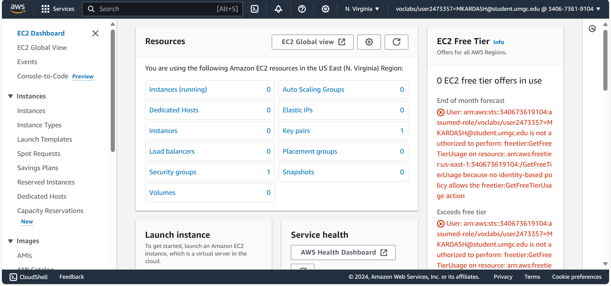

From this information, I can assume that the lab was launched successfully.